Amazing Bridges

E-Project

User Guide

Group Members

|  |  |
| --- | --- |
| Enrollment ID | Name |
| Student1418818 | Muhammad Rahim Faisal |
| Student1416181 | Muhammad Areeb |
| Student1418138 | Owais Aslam |
| Student1416169 | Mobeen Ur Rehman |

**Group:** A

**Curriculum:** 7062

**Semester:** CPISM

**Supervisor:** Sir Shahryar



**Certificate of Recognition**

This certificate is awarded to the makers of the “Amazing Bridges” for their outstanding contributions to the world of Bridges.

Their dedication to providing accurate, up-to-date information and resources for bridges all around the world. The website's comprehensive coverage of bridges around the world like longest, highest, tallest, oldest and will give accurate information about bridges.

The makers of the Amazing bridges have demonstrated that they will present the information about the various famous bridges throughout the world. This certificate is a small token of appreciation for their tireless efforts and the positive impact they have had on the lives of so many users.

Presented on: February 17,2023.

Authorized Signature: ______________________________

**Acknowledgements**

We would like to express our sincere gratitude to everyone who has contributed to the successful completion of this project.

**Acknowledgements**

We would like to express our sincere gratitude to everyone who has contributed to the successful completion of this project.

Our heartfelt thanks go to **Sir Shahryar** for providing invaluable guidance and support throughout the entire process.

We are deeply grateful to our colleagues and team members for their hard work, dedication, and collaboration. Their efforts have been instrumental in bringing this project to fruition.

We would also like to thank our families for their love and support, which has allowed us to stay focused and motivated.

Finally, we extend our thanks to all those who have provided us with the resources and opportunities necessary to complete this project.

This project would not have been possible without the help and support of all of you. Thank you.

**Synopsis**

"Amazing Bridges is a website dedicated to showcasing some of the world's most incredible bridges. The site features stunning photographs and detailed descriptions of bridges from all around the globe, including some of the most famous and iconic structures such as the Golden Gate Bridge, Tower Bridge, and the Sydney Harbor Bridge. Visitors to the site can learn about the history, design, and engineering behind these amazing feats of architecture and infrastructure, as well as the unique challenges that bridge builders face when constructing these massive structures. The site also features articles and blog posts on topics such as the future of bridge design, the impact of bridges on local communities, and the importance of bridge safety.”

**Problem Statement**

Amazing Bridges website will present the information about the various famous bridges throughout the world. The information behind this creation must be added. The information of amazing bridges can be categorized based on zone wise (Longest, Tallest, Highest, Oldest etc.).

**Requirement Specification:**

The Web site is to be created based on the following requirements.

1. The Home Page should be created making use of Sections with a suitable

logo, the header section can be added which will show images of famous

bridges.

1. The site must contain the links to navigate through any category for the

information.

1. Links of monuments can be categorized by zone wise like (Longest, Tallest, Highest, Oldest etc.) apart from country wise link can be added.
2. History and information of the bridges can be added along with the images.
3. Gallery section can be added for viewing different images.
4. Feedback must be allowed to enter by the viewer.
5. Site map, Gallery, about us, Queries link, contact us link must be added.
6. The complete historic reason and its description must be allowed to get download as pdf or doc file.
7. The advertise section of bus, flights can be included for reaching the places.

1.Navbar(index.html)

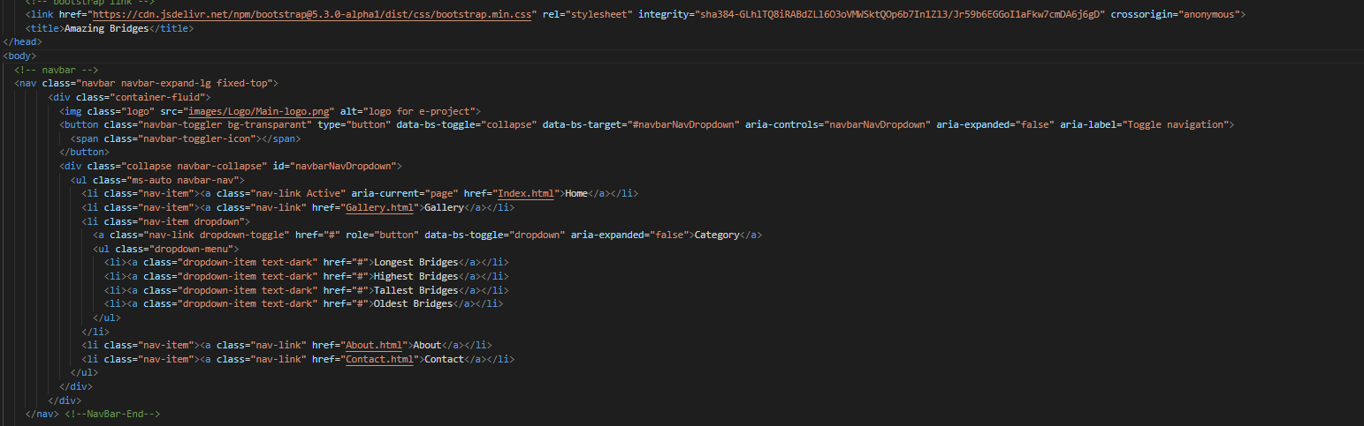



2.Home(index.html)

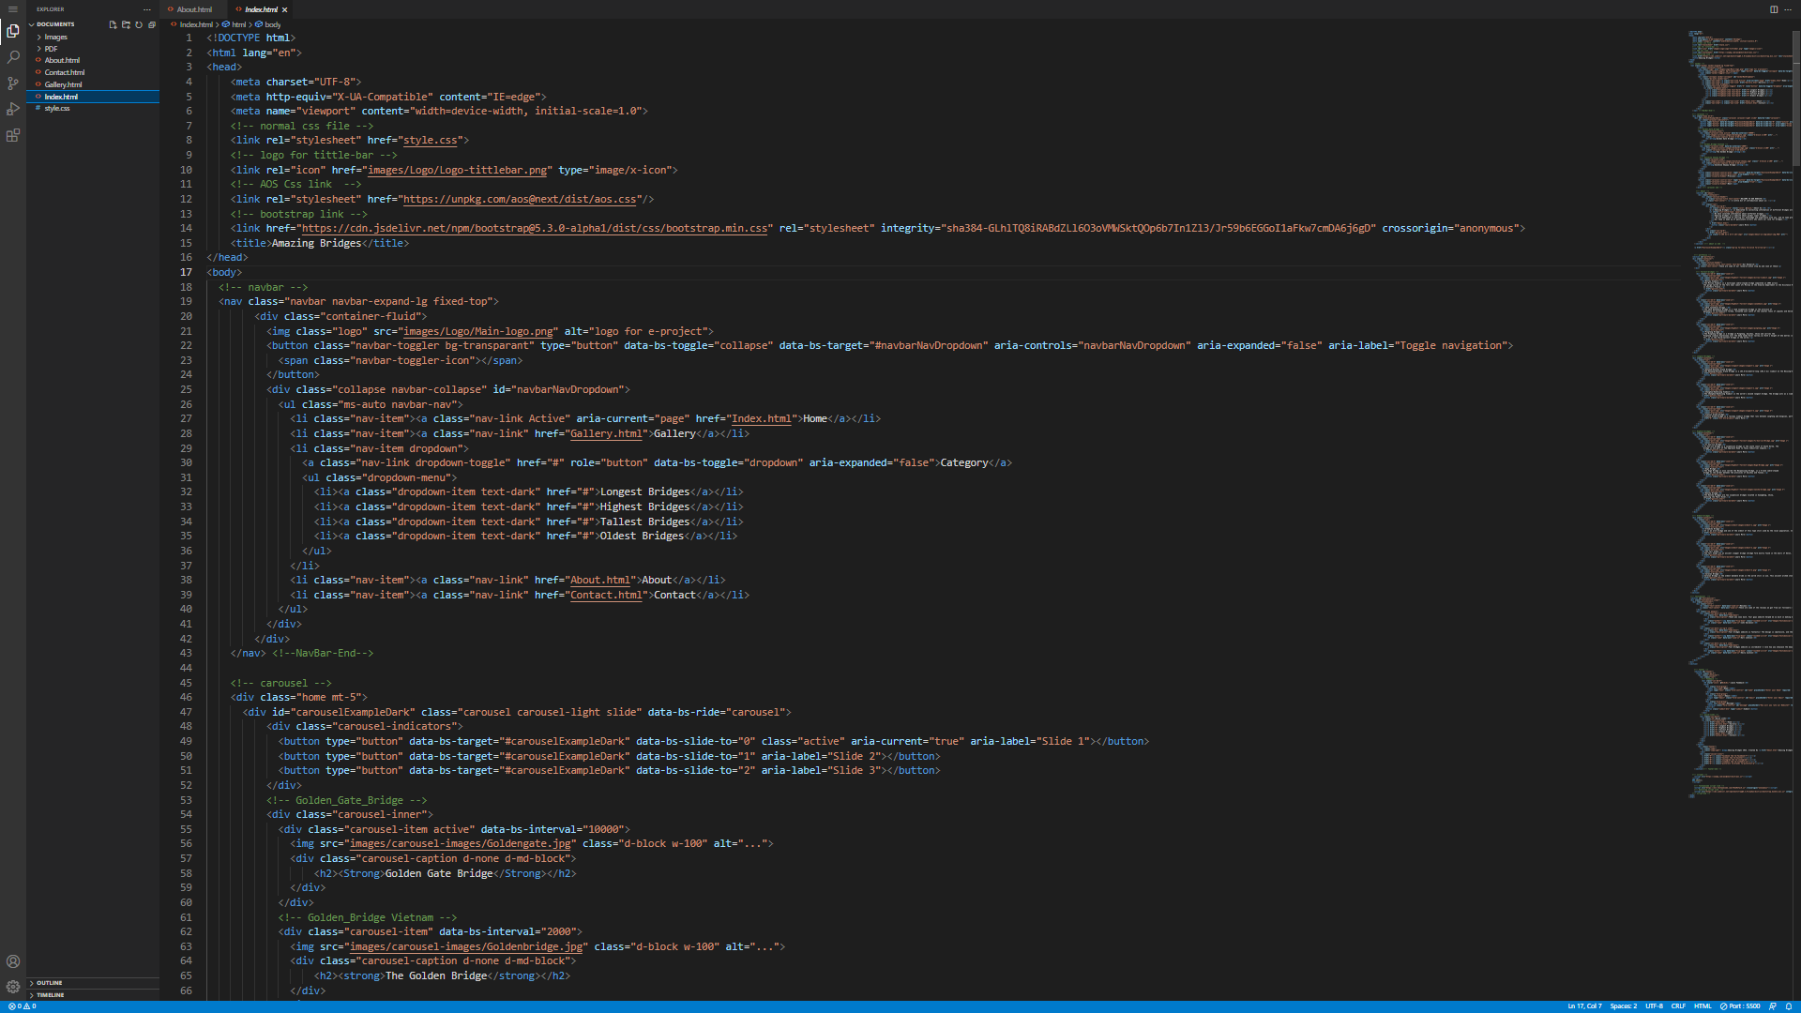

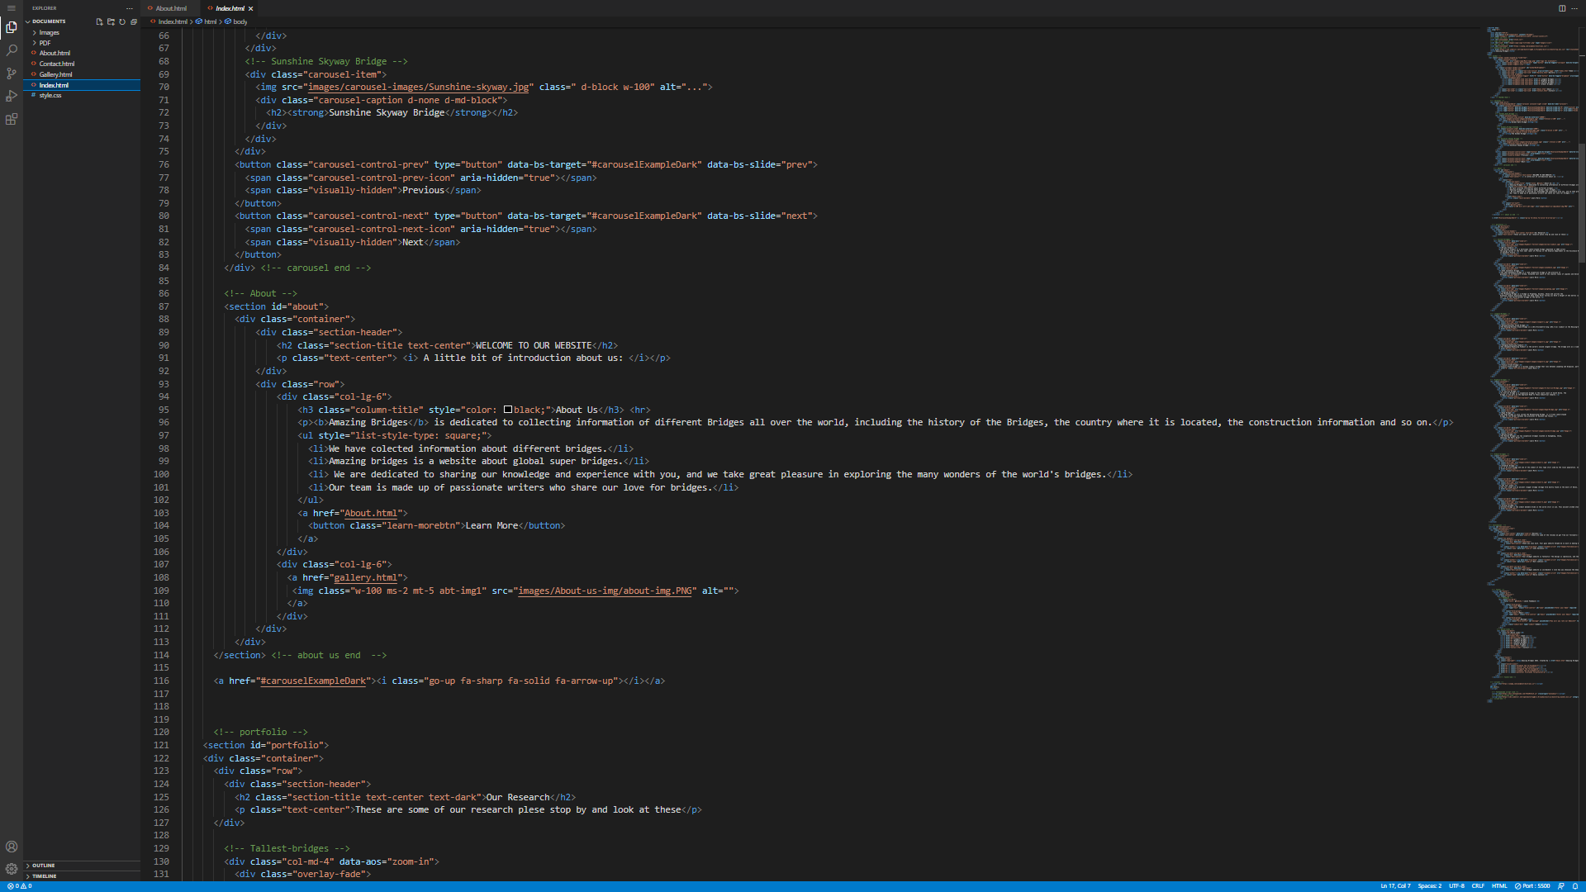

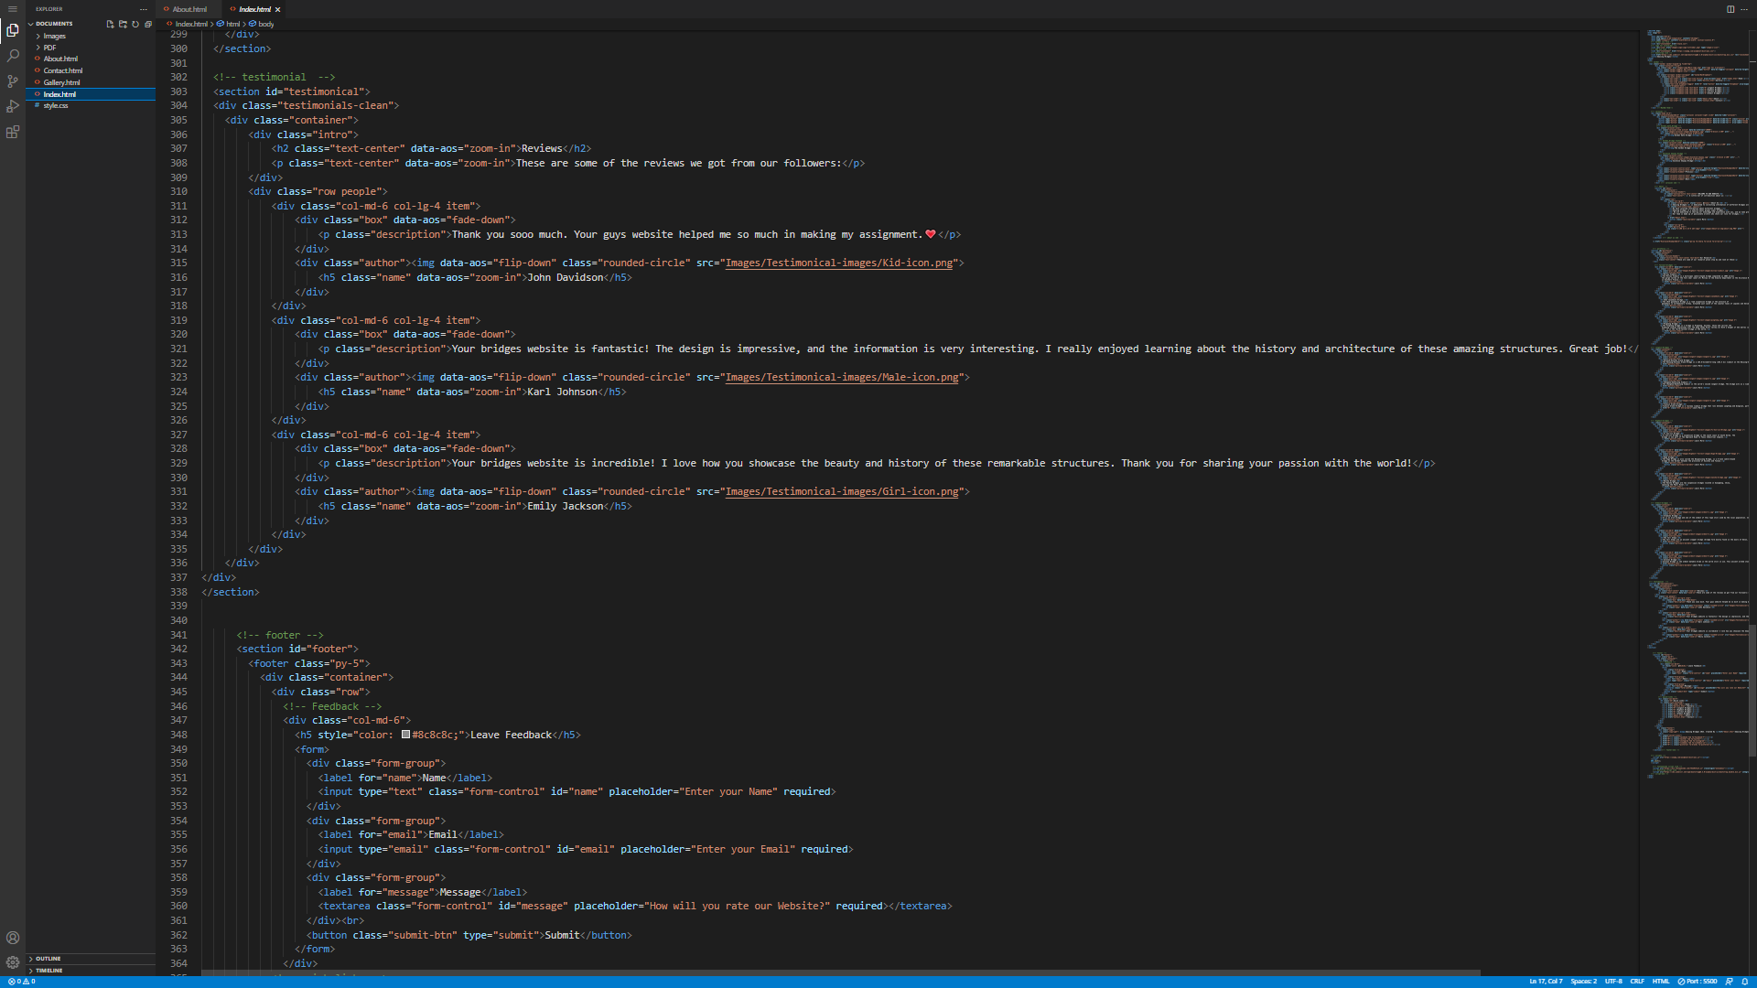

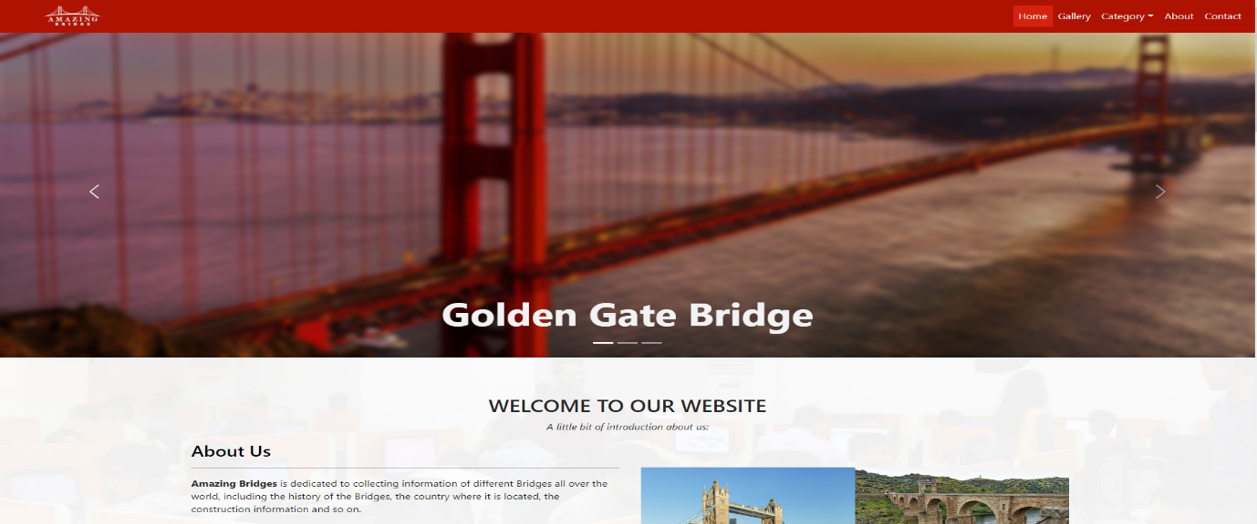

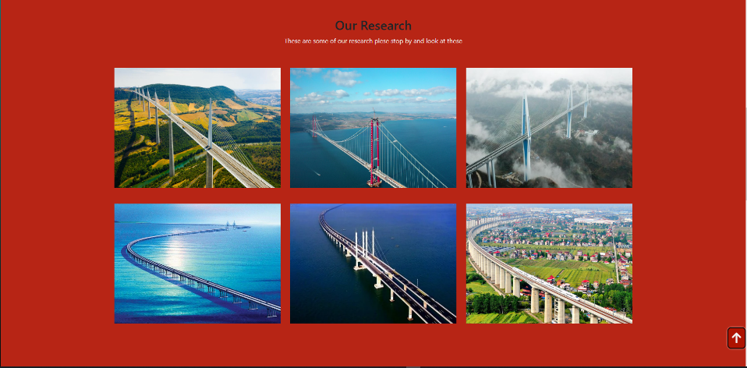

3. Gallery (Gallery.html) 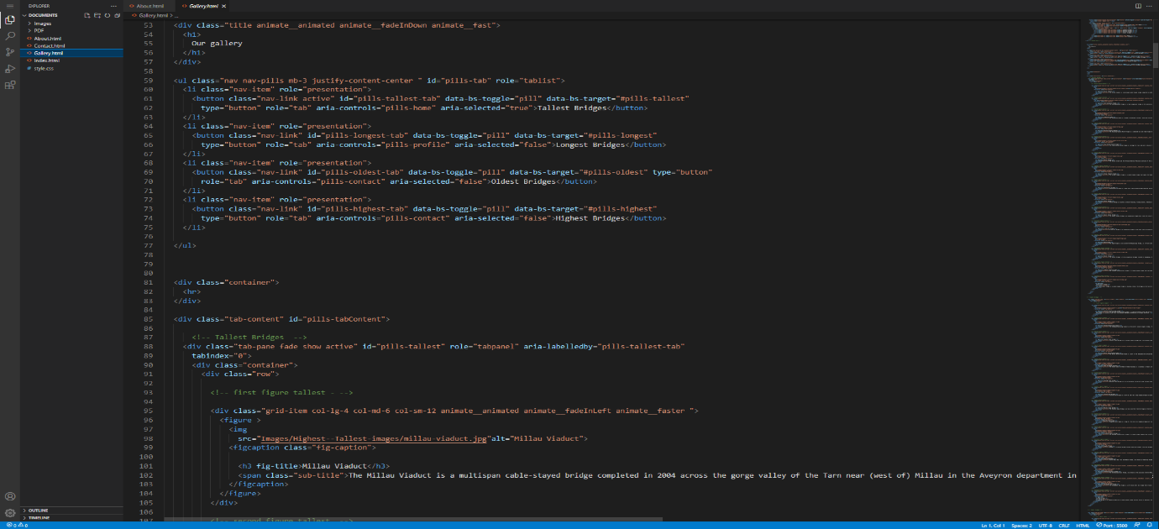

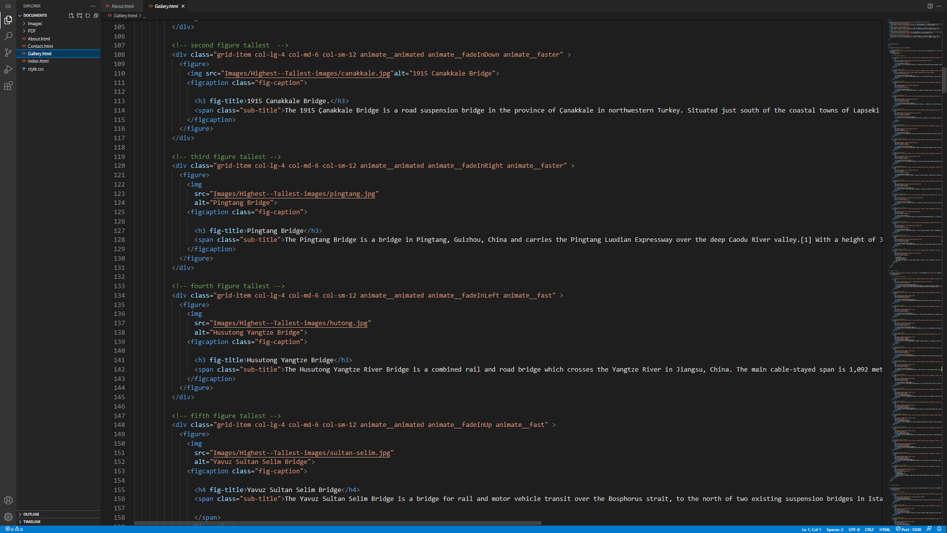

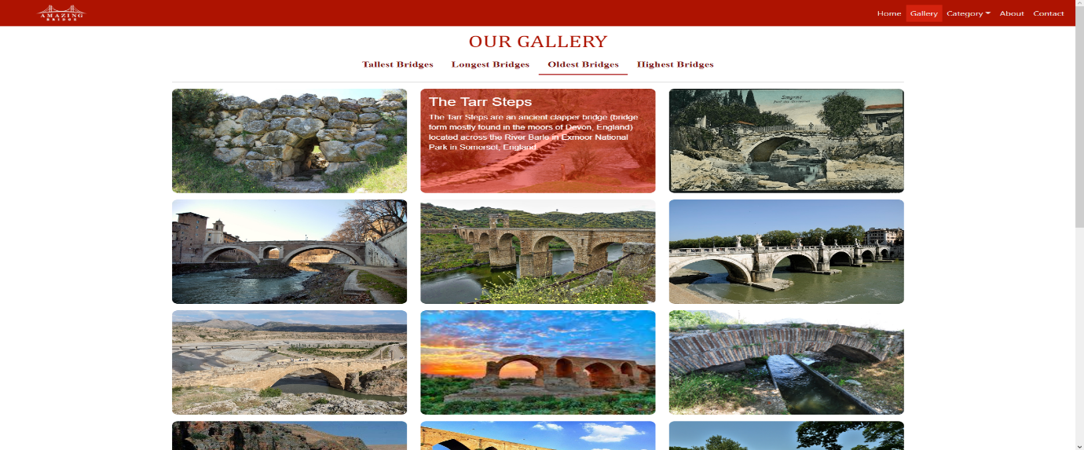

4.Extinct(extinct.html)

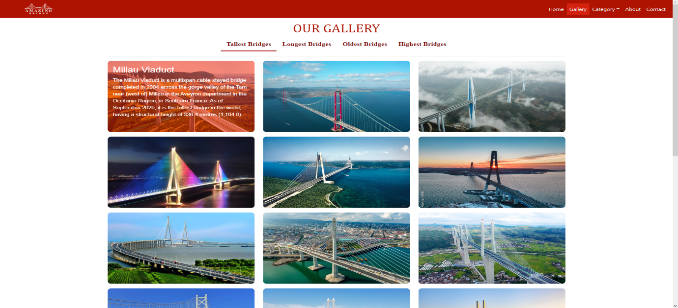

4.About us(About.html)

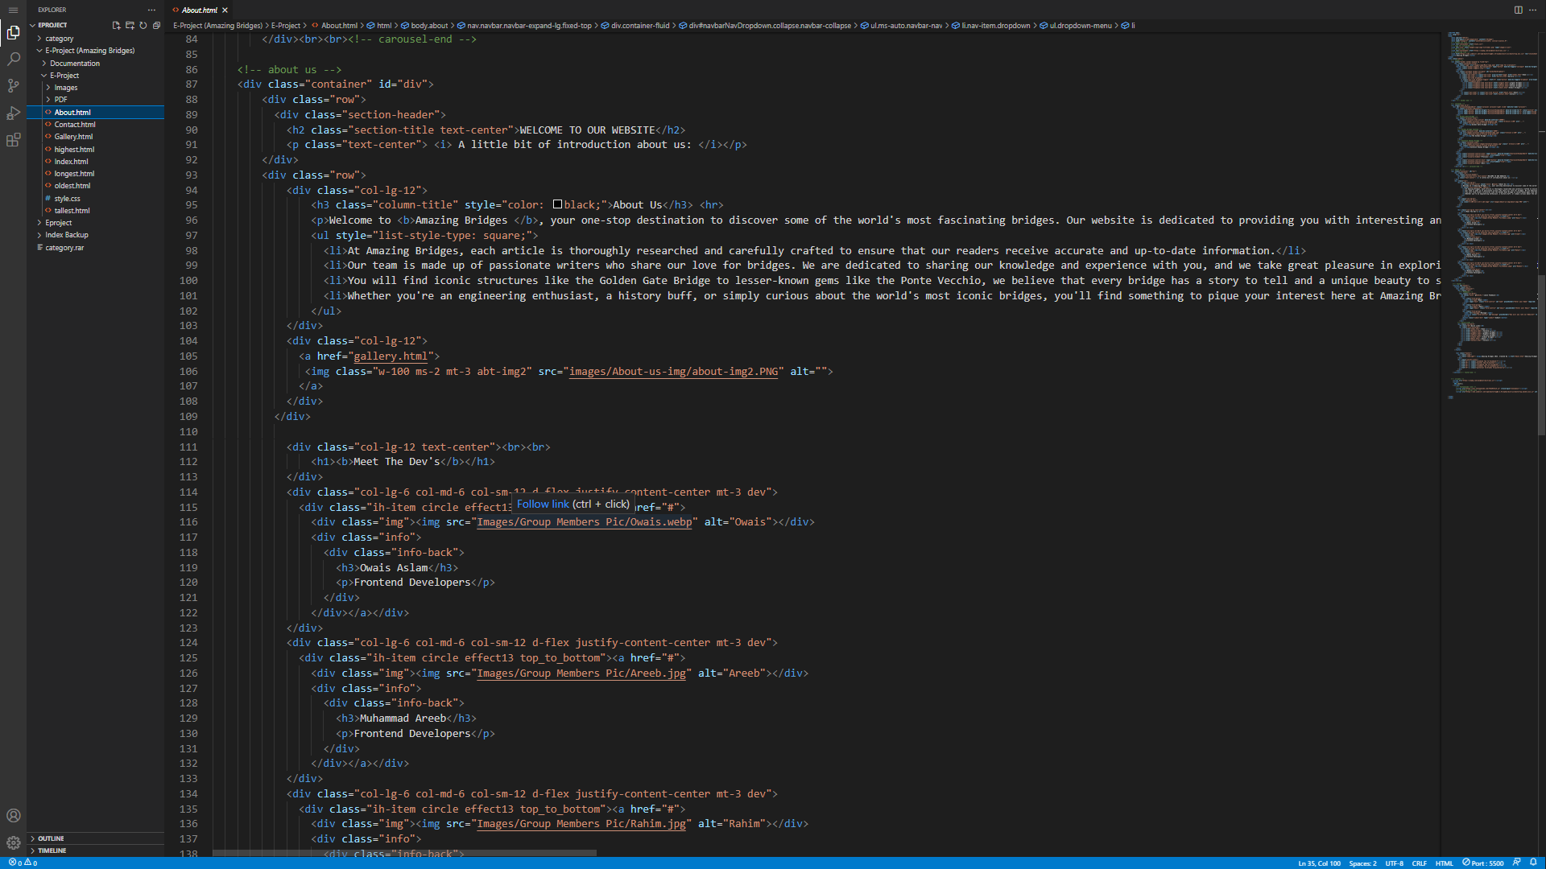

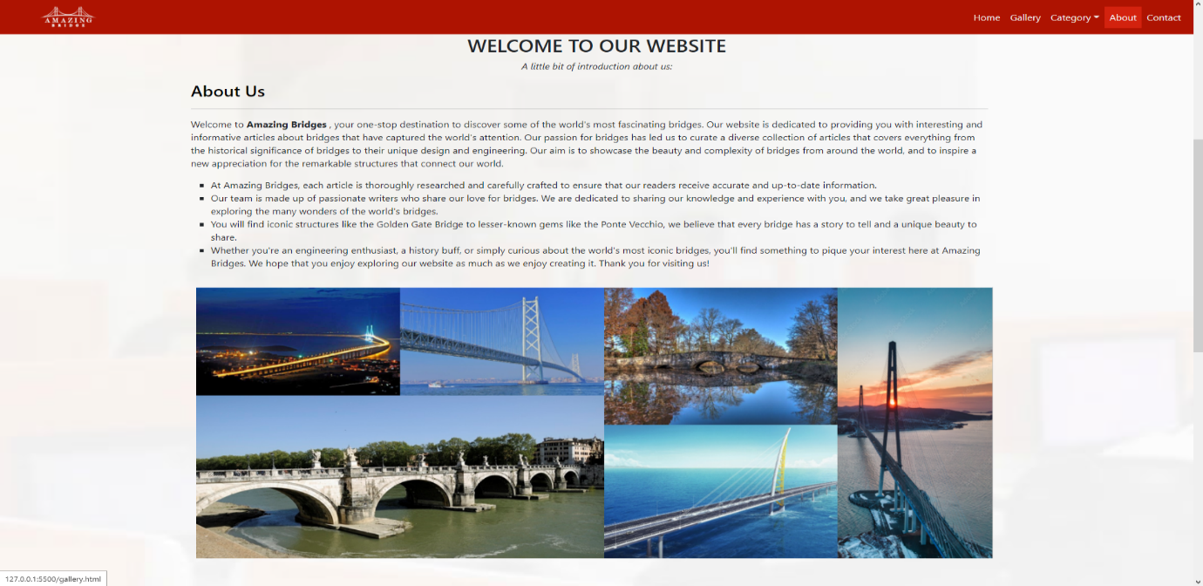

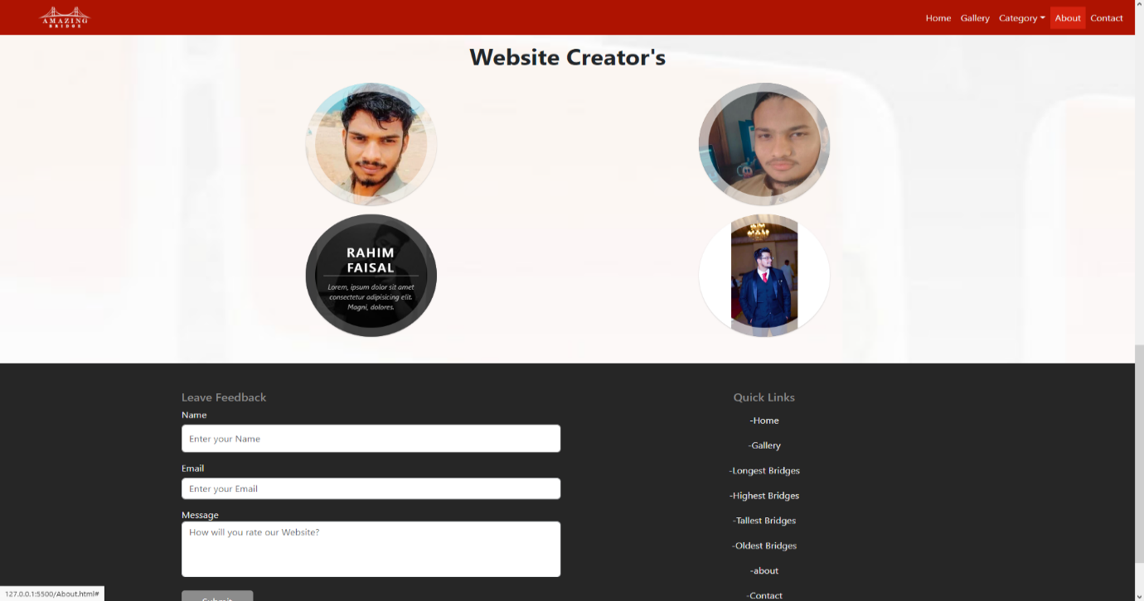

5. Contact(Contact.html)

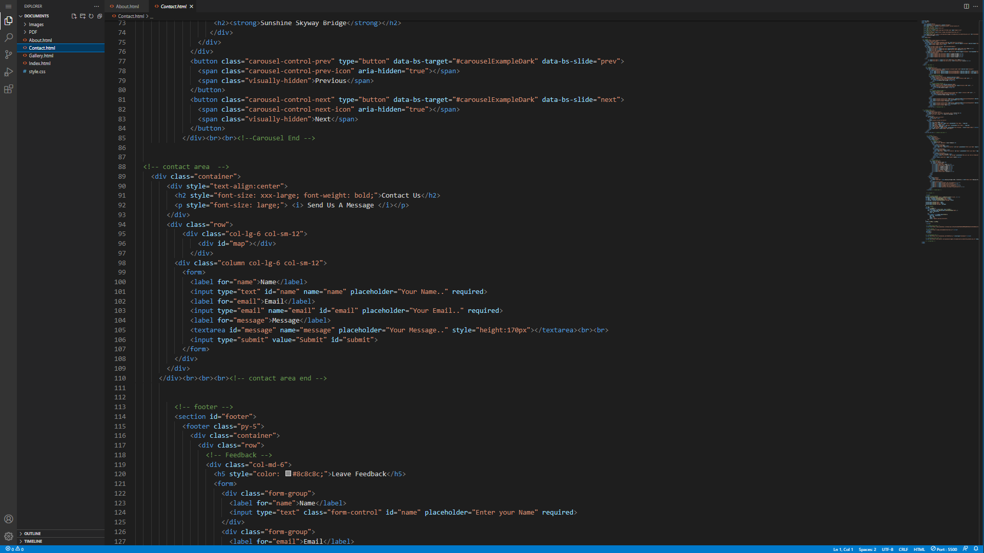

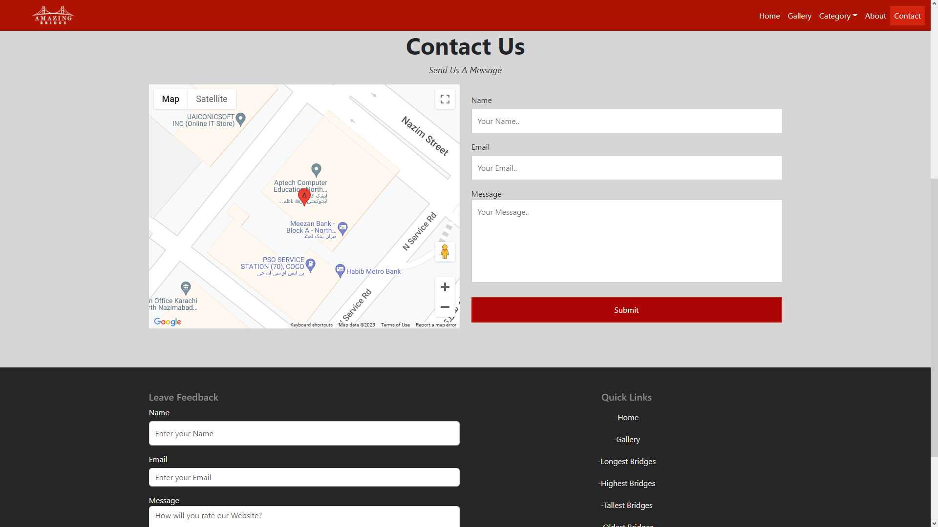

7. Categories(longest.html)

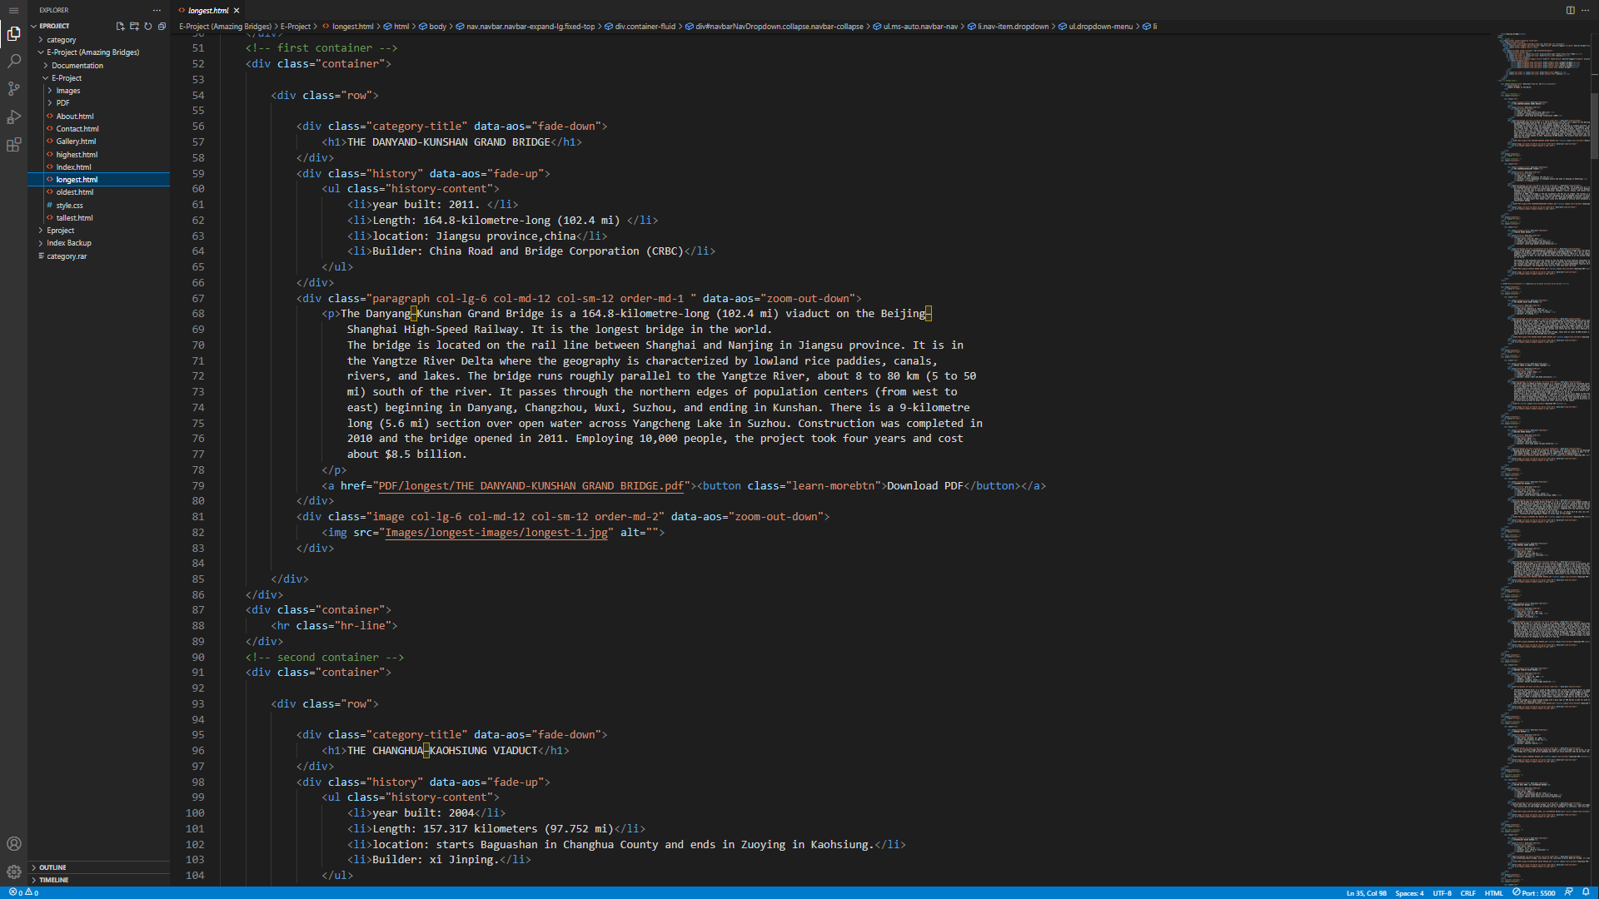

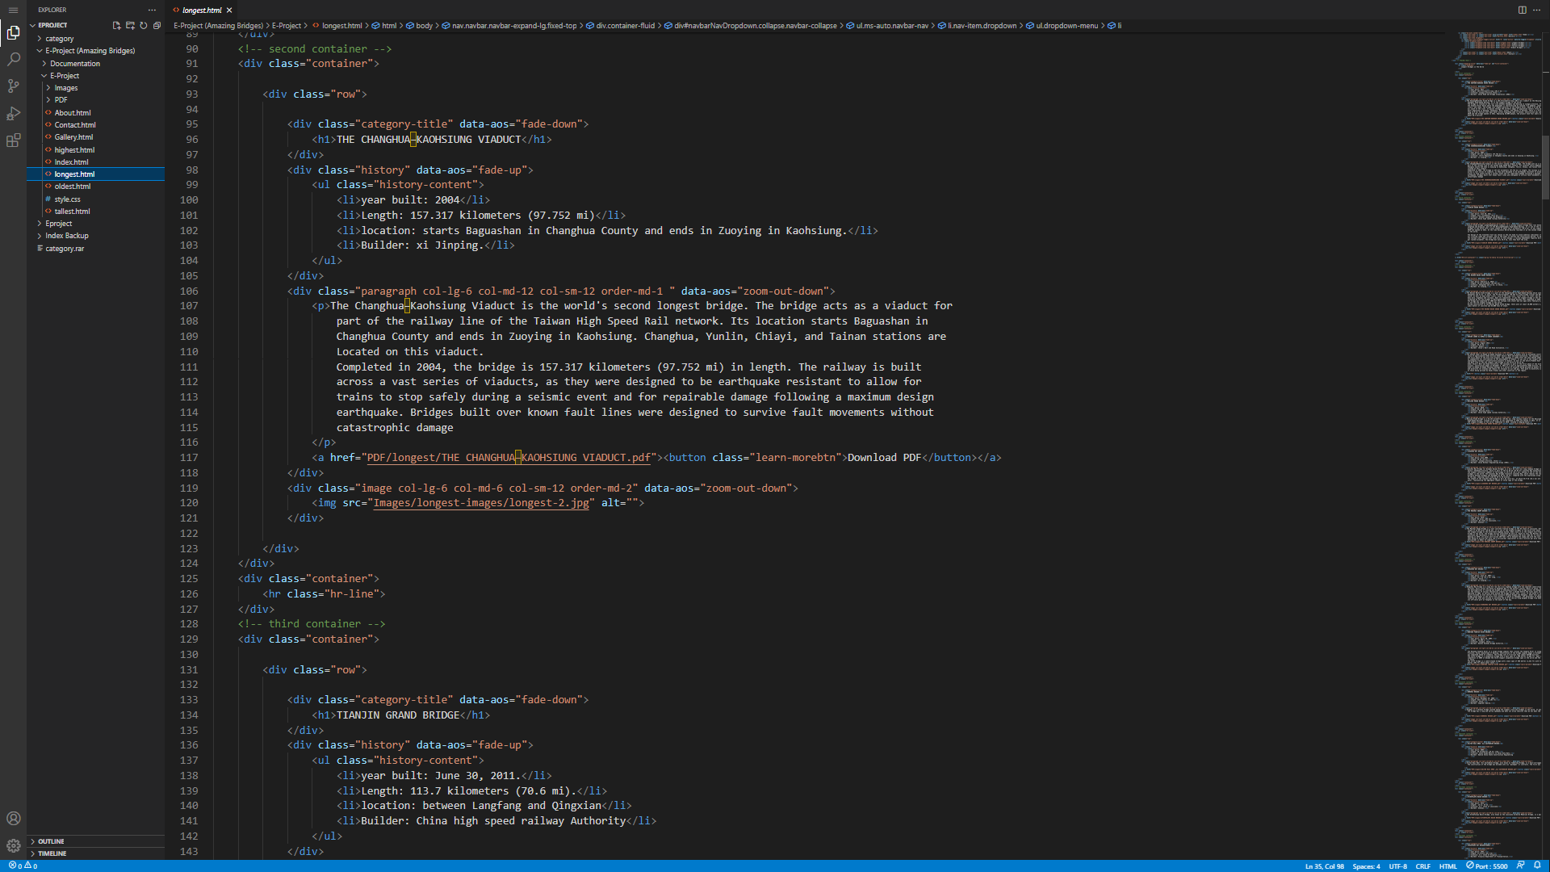

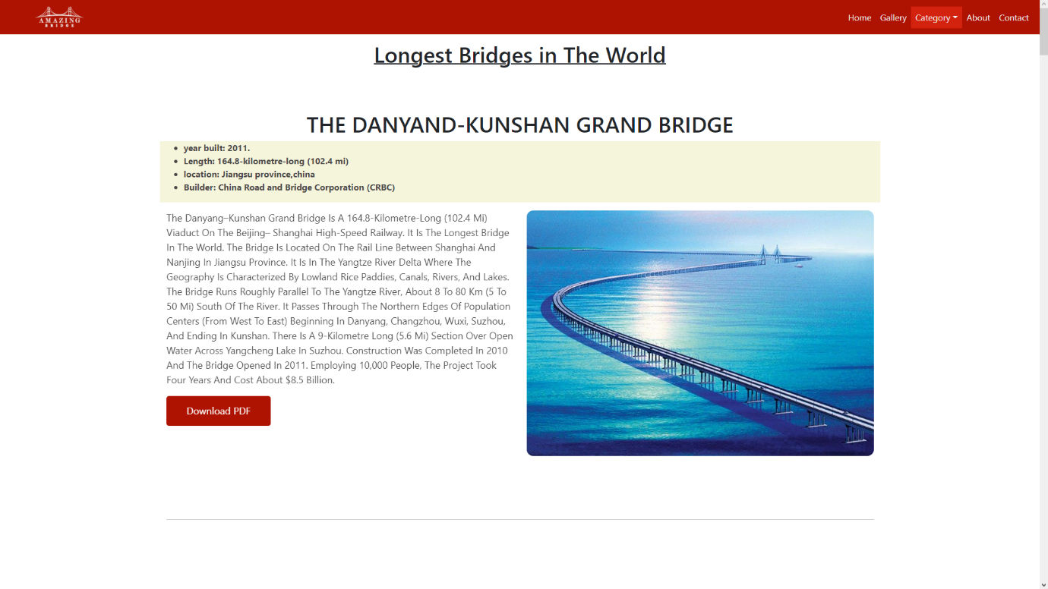

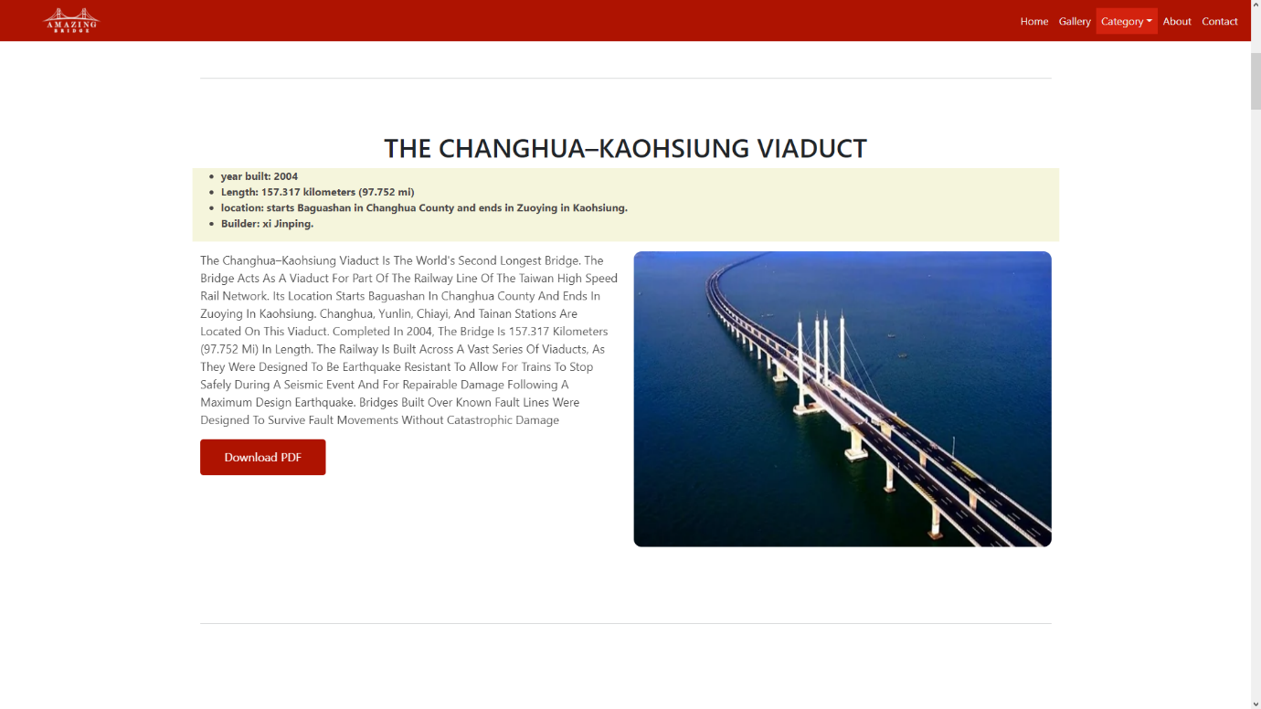

8. Categories (oldest.html)

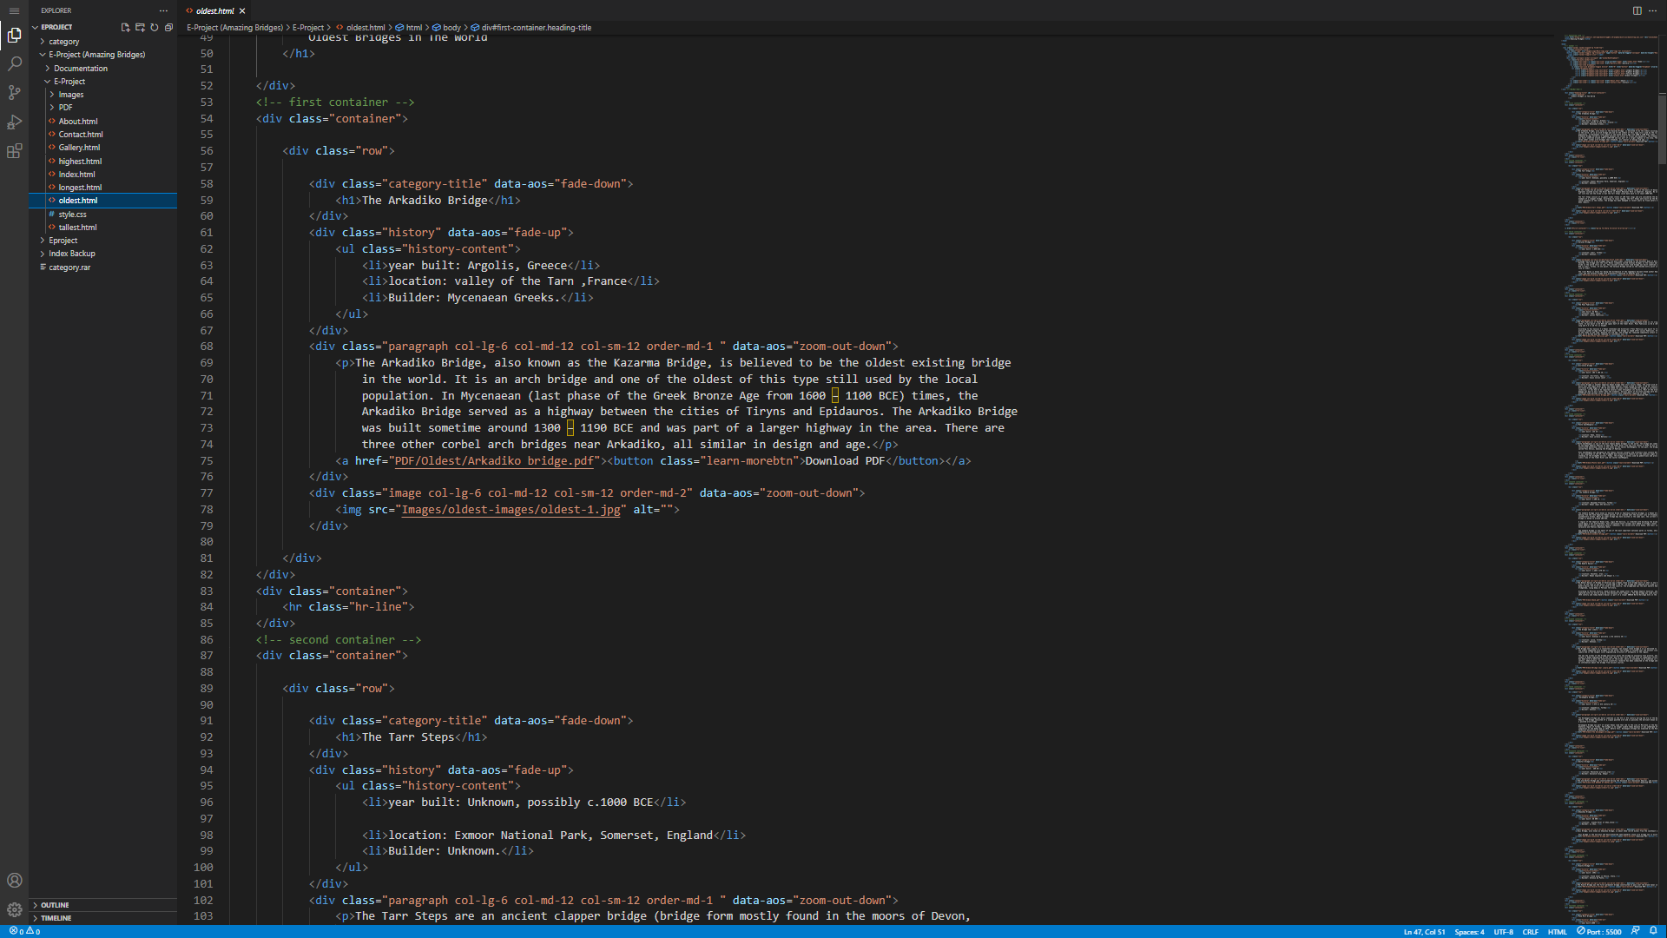

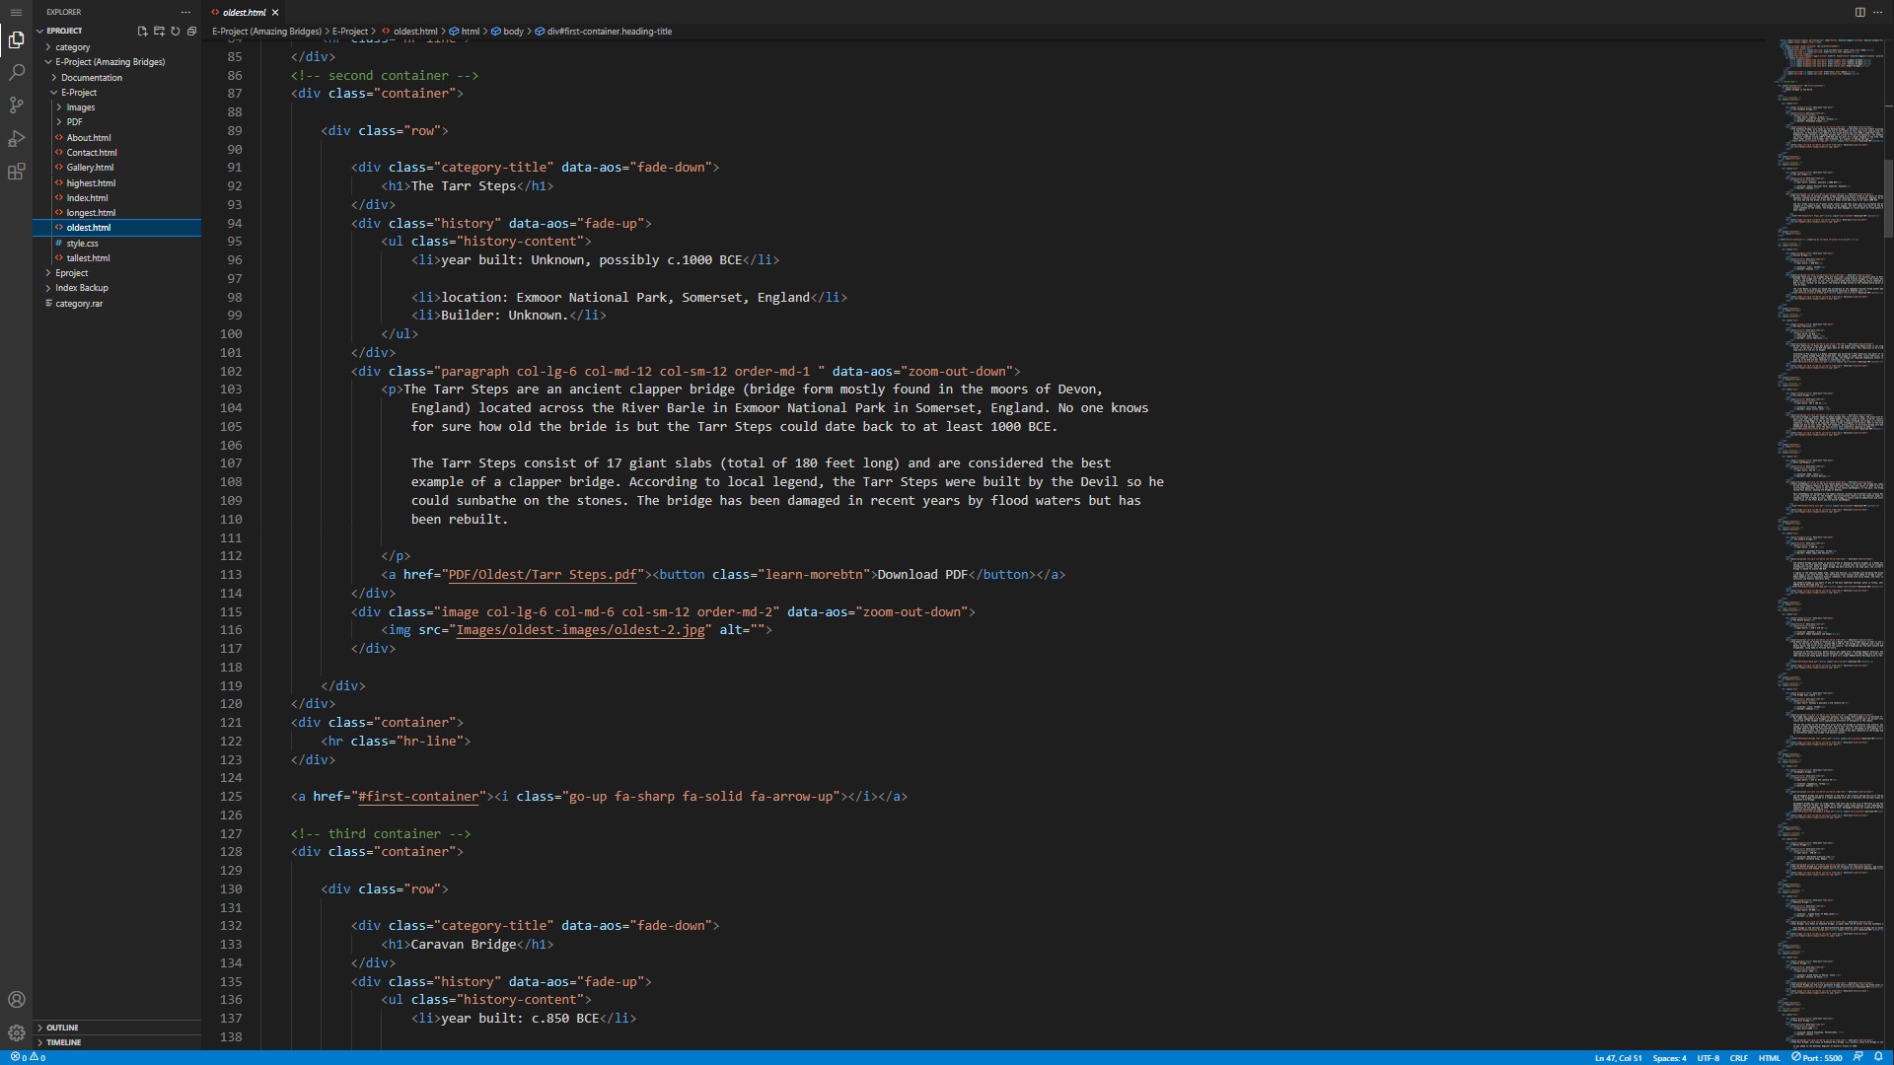

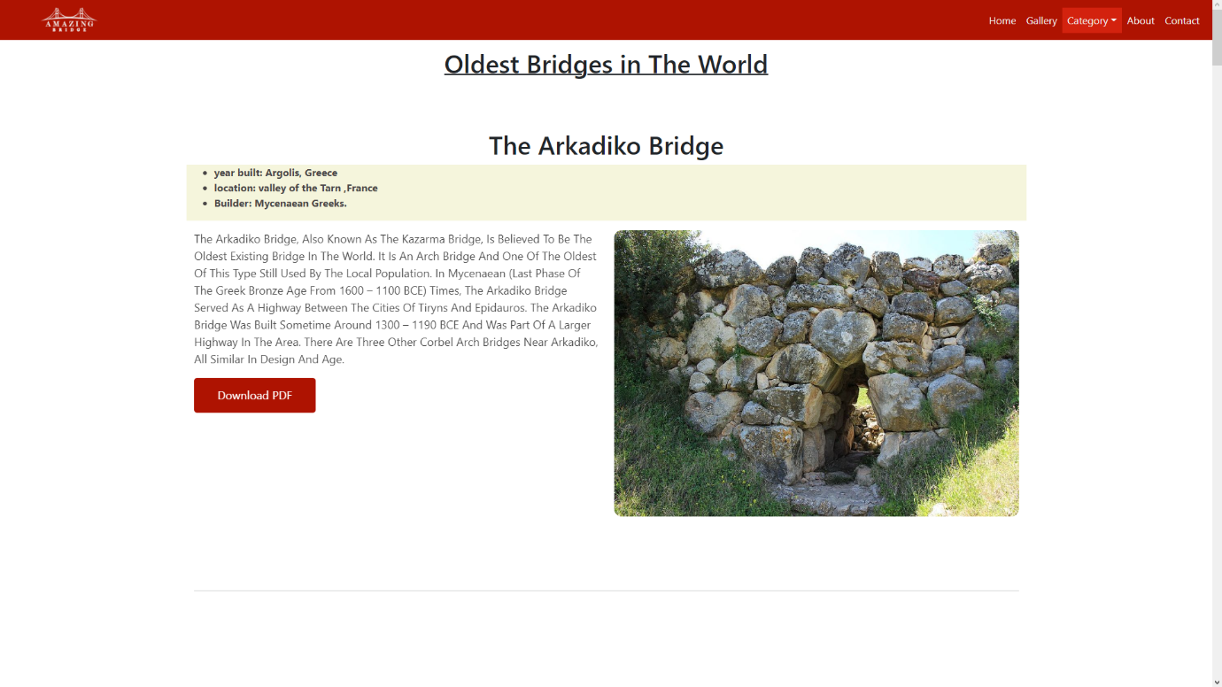

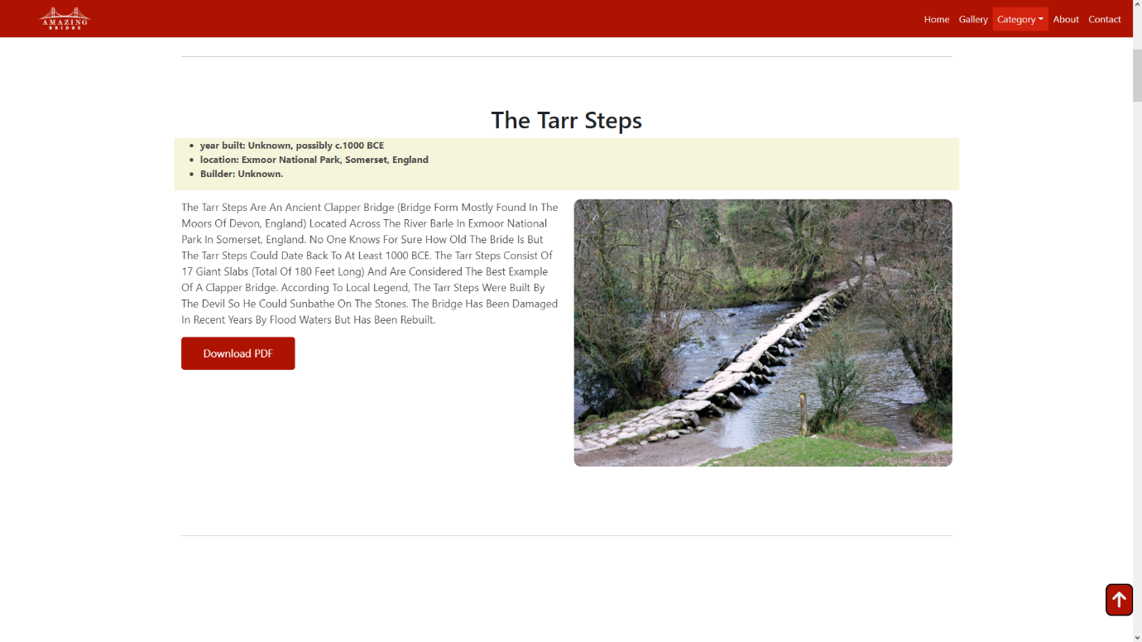

9. Categories (highest.html)

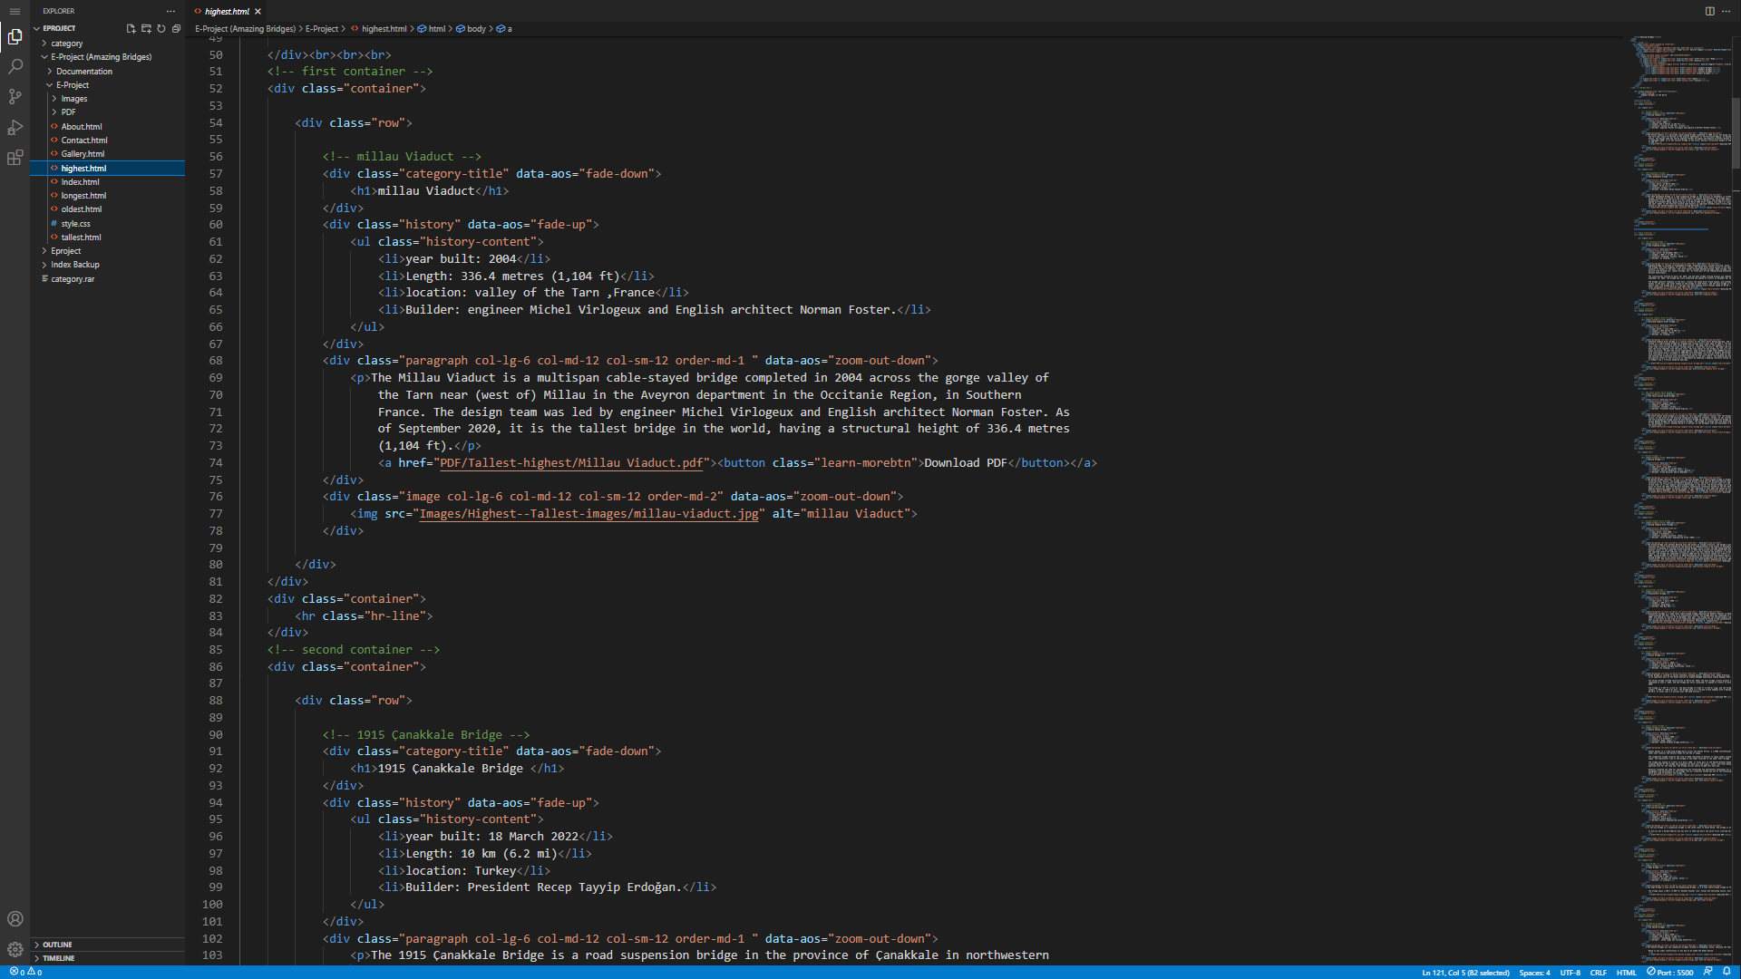

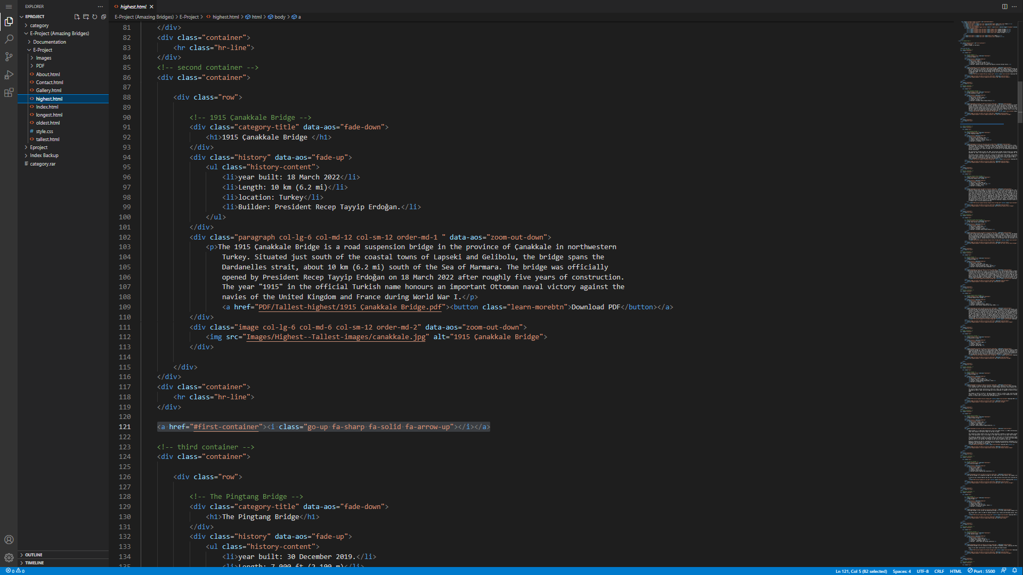

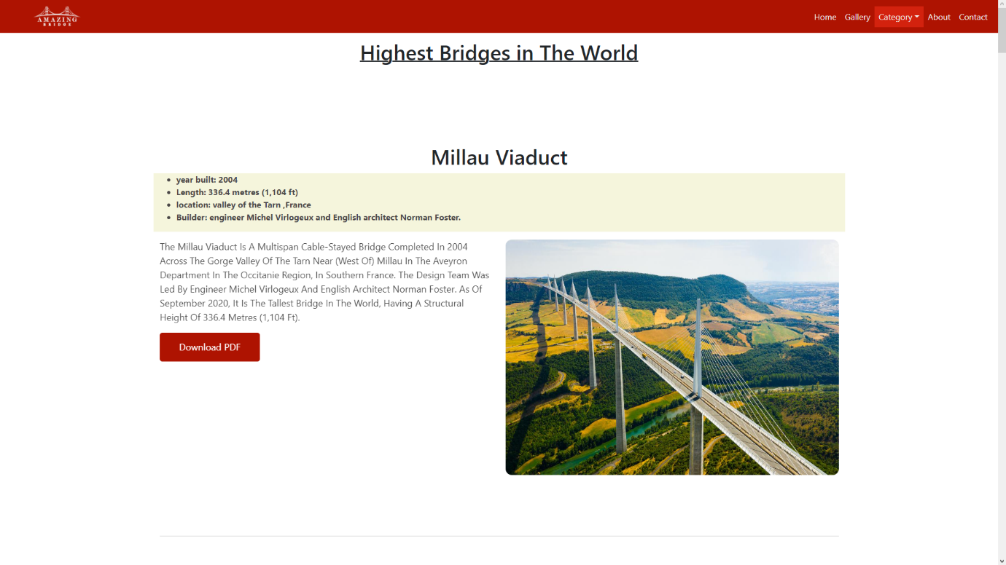

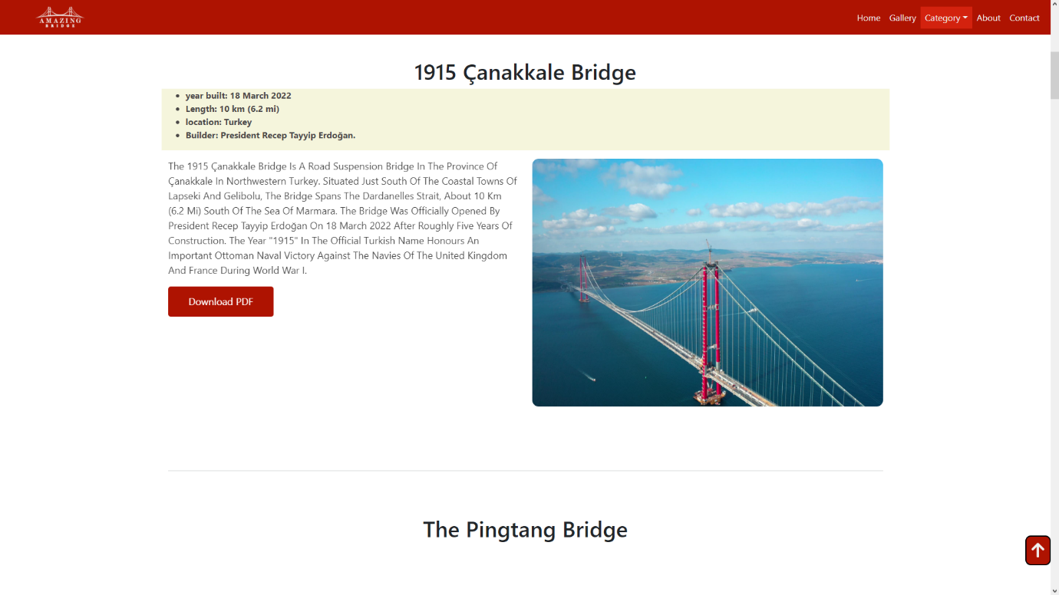

10. Categories (tallest.html)





